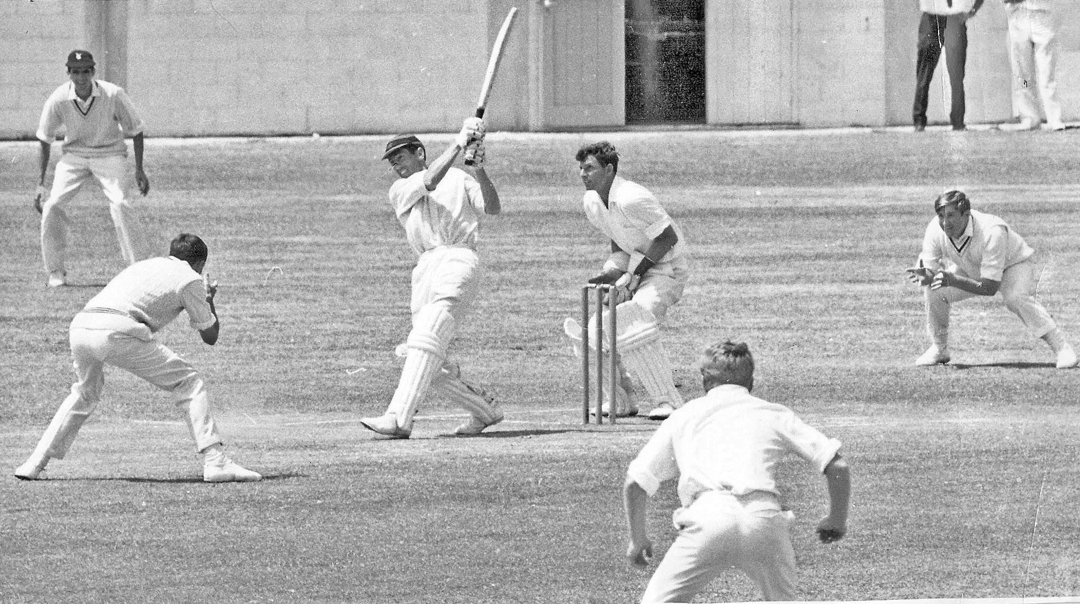

**GT Dowling hits a six against Central Districts at McLean Park Napier 15 January 1968. RM Schofield wick keeper, ML Ryan slip.**

**Dowling made 110 hitting 17 4’s and 2 6’s.**

**Central Districts 469/9 declared. Canterbury 226 and 74/5. The match was drawn**